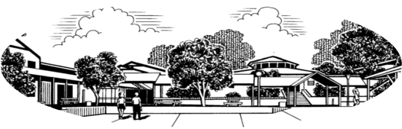
Northlakes High School
“Together we Achieve”

Dear parents and caregivers,

As a part of the Stage 5 History and Geography syllabi in Year 10, your child may be required to watch and study electronic media related to the content being studied this year. This may include:
- Films such as:

- Wog Boy M  - Schlindler’s List M  - Forrest Gump M  - The Boy in the Striped Pyjamas M  - Escape from Sobibor PG | - They’re a Weird Mob PG  - Threads M  - The Sapphires PG  - Rabbit Proof Fence PG  - Ghandi PG

- Documentaries, Youtube Clips and social media clips that may relate to such subjects as The Holocaust, The Stolen Generation, Reconciliation, The Cold war, The Vietnam War and Era, Geographical Issues in Australia, Human Rights, Future Challenges and Migration

The films which are rated M may contain adult and violent themes, coarse and violent language and violence.

If you do not want your child to watch these films, please return the slip below to indicate your decision. Alternatively, please indicate that you give permission for your child to watch and study these films during the school year in their History and Geography classes and return the slip below.

Sincerely,

Anna Howard
HT HSIE
Northlakes High School

I (please circle one) DO / DO NOT give permission for my child

_____________________________________________ of class _______________________
to watch the above films for the purpose of historical or geographical study. I understand that these movies may be is Rated M and my permission is required to allow my child to watch this movie in class.

Name: ___________________________________________

Signature: ___________________________________________

Date: ___________________________________________

