Topic: Picture Books
Kick Start Questions
True or False: Circle the correct answer.
Q. 1. -The starfish swarmed. Garfish gathered.
this is alliteration T/F
-A pain grew and flowered deep inside her
this is a metaphor T/F
3 marks
-The Theefyspray was coloured like a rainbow.
this is not a simile T/F
Prefixes
Q. 2. Write prefixes in front of the following word. Choose from un-, hemi-, mis-, dis-, or anti-.
- _____conduct | - _____bacterial | - _____ability  6 marks
- _____believable | - _____sphere | - _____biotic
Q.3.Now choose the correct word from above to fill in the gaps below.
a) Australia is in the Southern ________________________________
b) Your ______________________ has earned you a Friday afternoon detention.
c) Don’t look at it as a _____________________ but rather as a physical challenge.
d) The medicine was _____________________________.
5 marks
e) Your story is totally ____________________________.
Past, Present and Future tense
Q. 4. Complete the table below with the correct verbs for the tense.
Past | Present | Future
Walked | walk | Will walk
 | Go
Shook
 |  | Will sing
Was
 | See
 | Strike
Will write
14 marks

Spelling
Q.5. Each line has one spelling mistake. Write the correct spelling in the box.
- The fischerman broke his line.
- The fish were hiding in the shaddows.
- The fins of friendly fish’s flutterd in the fresh water.
- Beatifull fish are found in the Great Barrier Reef.
- When the sunlight hits the shiney scales they glitter.
- The old turtle remebered her birth place.
Suffixes.
6 marks
Q. 6. Write suffixes at the end of the following. Choose from the following –ion, -ful, -ment, -ing, -shop or –ism.
- shine____________
- champion_________
- transit____________
- capital____________
- fulfil______________
6 marks
- Meaning__________
Write down what you think this picture is trying to tell you.
Q.7.
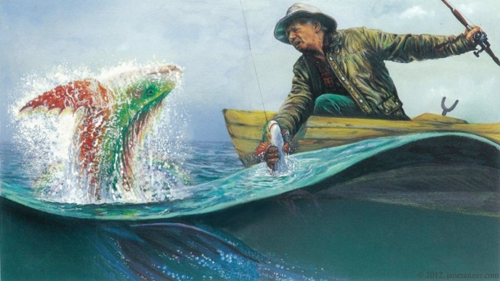
__________________________________________________________________________________________________________________________________________________________________________________________________________________________________________________________________________________________________________________________________________________________________________________________________________________________________________________________________________________________________________________________________________________________________________________________
Total /40 Marks
5 marks

