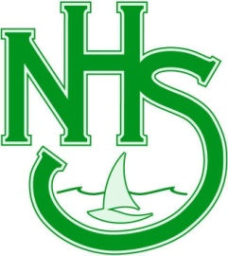
Northlakes High School
Assessment Task 4 (a)
Year 8 English
Subject/Course: Year 8 English (Supported Learning Class)
Unit or Topic: My Girragundji – Novel Study
Assessment Task Number: 4 (a)
Assessment Task Name: Visual Representation
Weighting: 15%
Due Date: Week 3, Term 2, 2017
Objectives
- Objective C - think in ways that are imaginative, creative, interpretive and critical

- Objective D- express themselves and their relationships with others and their world

Outcomes Assessed:

- EN4-6C: identifies and explains connections between and among texts

- EN4-7D: demonstrates understanding of how texts can express aspects of their broadening world and their relationships within it

Task Description: You will be given 2 lessons of class time to complete this task.

Students are to create a new front cover of “My Girragundji”. You are to include all the visual literacy techniques studied in class to communicate the central themes and concepts of the story. You can include words and pictures on your visual representation.

It should be one A4 page in size.
You must include the following:
- Include a plan of your visual representation (completed in class).
- Creative use on visual literacy techniques in communicating main themes and concepts
- Correct grammar, spelling and punctuation.
Submission requiremenTS

- This is a compulsory assignment for all Year 8 English students.
- This assignment is worth 15% Yearly Mark.
- This task therefore has a significant influence on your final ranking within the class group.
- Non-completion of this task may result in a poor grade or a letter home.
- Completed assignments must be submitted early if a student knows that he or she will be absent on the due date

