Spooks Incorporated
Kick Start Questions Term 1
Q1 Match the term from the box that best fits the example provided.
slang rhyme simile metaphor alliteration

- She sat up in bed and hit her head. _________________ (rhyme)
- The shadow was like a ghost in the night. ________________ (simile)
- It was coming closer, coming along the hall. ______________ (alliteration)
- The shadow was a fearsome ghost flickering on the wall. ____________ (metaphor)
- “We’ll be having a barbie this arvo,” said Dad. _____________ (slang) 5 marks
Q2 What is the moral of a story? (The moral of a story is the message to be learned from the story.)
_______________________________________________________________________________
2 marks
Q3 Read the following paragraph and:
a) circle 14 nouns
b) underline 5 pronouns
c) place a cross over 4 adjectives.
And there in the dark hall he stood. The ghost of Ned Kelly. He had a steel helmet over his head with a slit cut out for the eyes. His chest was covered with steel plates. In one hand was a candle and in the other was a revolver. Green eyes glowed through his helmet.
23 marks
Q4 Place these words into alphabetical order:
slowly, ghost, helmet, glowed, through, green
- __________
- __________
- __________
- __________
- __________
- __________
- ghost 2. glowed 3. green 4. helmet 5. slowly 6. through
6 marks

Q5 Read the following passage and answer the questions. Make sure you circle the clue word, underline the question and underline the answer in the passage. Write your answer in full sentences. For each question circle whether it is a Right There (RT) Question, a Think and Search (T&S) Question or an On My Own (OMO) Question. You will be awarded 1 mark for each question for circling the correct question type.
Just over two hundred years ago, Australia was a small colony with thousands of convicts. The first bushrangers, or outlaws, were convicts who ran away to the bush to escape from the terrible conditions and the mean, brutal guards. The escaped convicts were known as bolters. Many bolters tried to live off the land by hunting and fishing or by stealing food and clothing from free settlers. Most of the bolters were run down and caught within days of escaping and punished with one thousand lashes. Some of the bolters were not recaptured and lived with friendly aborigines. Other bolters who weren’t recaptured took up arms against the law and became Australia’s first bushrangers.

A) How long has it been since Australia was a small colony? RT T&S OMO 2 marks
_______________________________________________________________________________
B) Give 2 reasons why convicts ran away to the bush. RT T&S OMO 2 marks

__________________________________________________________________________________
c) What happened to bolters who were not recaptured? RT T&S OMO 3 marks
__________________________________________________________________________________
__________________________________________________________________________________
d) What do you think it would it have been like for convicts living in the bush? RT T&S OMO
__________________________________________________________________________________
__________________________________________________________________________________
3 marks

Question 6 4 marks
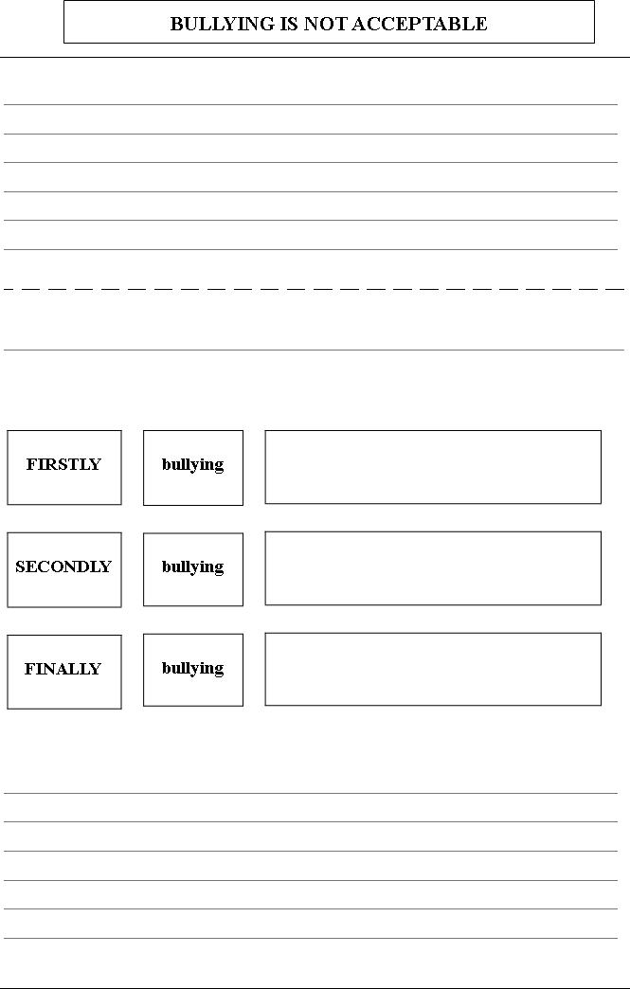
Conclusion
Introduction
Linking sentence
Heading

Question 1 | /5
Question 2 | /2
Question 3 | /23
Question4 | /6
Question 5 | /10
Question 6 | /4
Total | /50

