Topic: Picture Books
Kick Start Questions
True or False: Circle the correct answer.
Q. 1. -The starfish swarmed. Garfish gathered.
this is alliteration T/F
-A pain grew and flowered deep inside her
this is a metaphor T/F
3 marks
-The Theefyspray was coloured like a rainbow.
this is not a simile T/F
Prefixes
Q. 2. Write prefixes in front of the following word. Choose from un-, hemi-, mis-, dis-, or anti-.
- misconduct | - antibacterial | - disability  6 marks
- unbelievable | - hemisphere | - antibiotic
Q.3.Now choose the correct word from above to fill in the gaps below.
a) Australia is in the Southern hemisphere
b) Your misconduct has earned you a Friday afternoon detention.
c) Don’t look at it as a disability but rather as a physical challenge.
d) The medicine was antibiotic
5 marks
e) Your story is totally unbelievable.
Past, Present and Future tense
Q. 4. Complete the table below with the correct verbs for the tense.
Past | Present | Future
Walked | walk | Will walk
Gone | Go | Will go
Shook | shake | will shake
sung | sing | Will sing
Was | Are | Will be
Saw | See | Will see
Struck | Strike | Will strike
Wrote | write | Will write  14 marks

Spelling
Q.5. Each line has one spelling mistake. Write the correct spelling in the box.
- The fischerman broke his line. fisherman
- The fish were hiding in the shaddows. shadows
- The fins of friendly fish’s flutterd in the fresh water. fishes
- Beatifull fish are found in the Great Barrier Reef. beautiful
- When the sunlight hits the shiney scales they glitter. shiny
- The old turtle remebered her birth place. remembered
Suffixes.
6 marks
Q. 6. Write suffixes at the end of the following. Choose from the following –ion, -ful, -ment, -ing, -ship or –ism.
- shining
- championship
- transition
- capitalism
- fulfilment
6 marks
- Meaningful
Write down what you think this picture is trying to tell you.
Q.7.
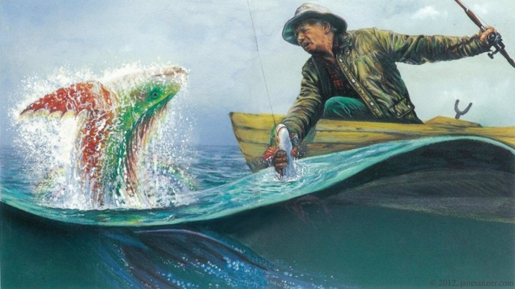
Total /40 Marks
5 marks

Students’ own interpretation

