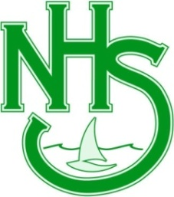
North Lakes High School –Year 8 Geography Skills Register
Teacher:_________________ Year:____________________

 |  | Date Completed | Example of Activity
Maps | - use an atlas
 | - use various types of maps: physical, political, topographic, thematic
 | - identify and use elements of maps, including legend, direction, title, scale, border
 | - distinguish between different types of map projections
 | - locate features on a map using:
 | - latitude and longitude
 | - area and grid references
 | - identify physical and cultural features on a map
 | - measure distances on a map using a linear scale
 | - identify scale as written, linear or representative fraction
 | - use the points of a compass to determine direction
 | - identify and interpret relief using shading, spot heights, colour and contour lines
 | - construct a sketch map
 | - read synoptic charts: wind direction and speed, pressure patterns, fronts and rainfall
Fieldwork | - use geographical instruments, including:
 | - a compass to determine direction
 | - a clinometer and tape
 | - weather instruments, a Beaufort wind scale and cloud identification charts
 | - vegetation identification charts
 | - collect and record data in the field, including:
 | - design and conduct interviews
 | - construct and implement surveys
 | - field sketch, diagram
Graphs and Statistics | - identify and calculate maximum, minimum, total, range, rank and average
 | - construct and interpret bar, column, line, climatic and proportional graphs
Photographs | - draw a line drawing
 | - distinguish between oblique, aerial, ground-level photographs and satellite imagery
 | - collect and interpret photographic images

