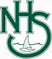

Year 7 Science

Working as a scientist

**HOMEWORK**

**BOOK**

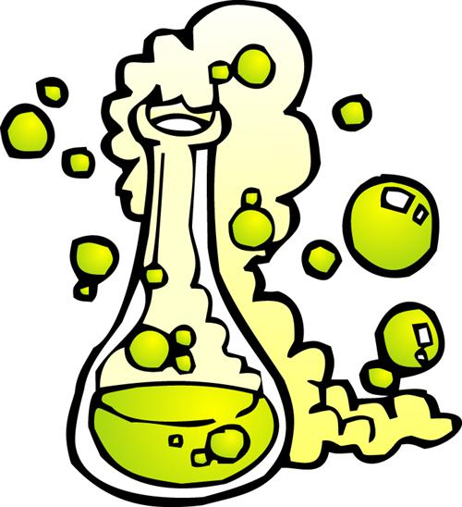

*Worksheet 1*

Safety in the laboratory

**Activity 1**

The picture shows some students in the laboratory. Some of these students are not following the safety rules and some are.

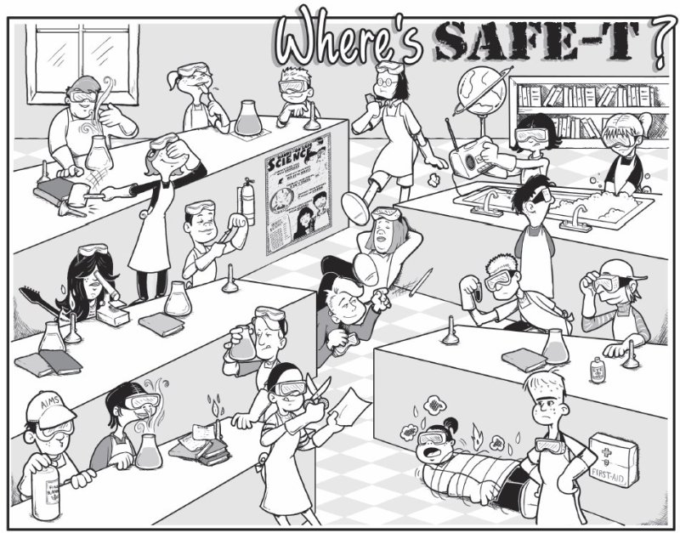

List five things that the students are doing correctly and five things that the students should not be doing in the science laboratory.

|  |  |
| --- | --- |
| **Do**  _____________________________________________________________________________________________________________________________________________________________________________________________________________ | **Don’t**  _______________________________________________________________________________________________________________________________________________________________________________________________________________________ |

**Activity 2**

Read each of the statements below. Circle **TRUE** if you think the statement is true, or **FALSE** if you think the statement is false.

|  |  |  |
| --- | --- | --- |
| 1. A science laboratory is like a kitchen, only more hazardous. | **TRUE** | **FALSE** |
| 1. A measuring cylinder is used for heating liquids. | **TRUE** | **FALSE** |
| 1. You should tie back long hair whenever you are doing an experiment. | **TRUE** | **FALSE** |
| 1. Safety glasses should be worn when doing an experiment. | **TRUE** | **FALSE** |
| 1. If you break a beaker by accident, you should try to hide it so you don’t get in trouble. | **TRUE** | **FALSE** |
| 1. You should push away other students to make sure you get the equipment you want. | **TRUE** | **FALSE** |
| 1. If you are unsure of what to do, you should ask a teacher. | **TRUE** | **FALSE** |
| 1. You should always follow the teacher’s instructions in order to keep yourself and others safe. | **TRUE** | **FALSE** |

*Worksheet 2*

Science equipment

Label each picture with the correct name of the equipment from the word list below.

|  |  |  |  |  |
| --- | --- | --- | --- | --- |
| test tube rack | watch glass | boss head | test tube | test tube holder |
| tripod | crucible | Bunsen burner | safety glasses | tongs |
| spatula | conical flask | clamp | heat proof mat | retort stand |
| thermometer | clay pipe triangle | evaporating dish | measuring cylinder | beaker |



*Worksheet 3*

Diagrams of equipment

Here are scientific diagrams of pieces of equipment. Name each piece of equipment by filling in the missing letters.

|  |  |  |  |
| --- | --- | --- | --- |
|  | t __ __ __  tu __ __ |  | __ __ amp |
|  | c __ __ __ __ l  fl __ __ __ |  | __ easu__ __ __ __  cy __ __ __ d __ r |
|  | t __ __ __ __ d  st __ __ __ |  | fil __ __ __  __ __ __ nel |
|  | b __ __ k __ __ |  | w __ __ __  __ a __ z __ |
|  | B __ __ s __ __  __ ur __ er |  | evap __ __ __ ting  __ __ __ __ n |

*Worksheet 4*

Find-a-word

1. Use the clues to work out each word. Write the answer in the answer column.
2. Find each word in the puzzle. (Hint: the number of letters is given in brackets in each case.) The first one has been done for you.



|  |  |
| --- | --- |
| **Clues** | **Answers** |
| Measuring ________ (8) | cylinder |
| Eye protection (6,7) |  |
| For measuring temperature (11) |  |
| For scooping small amounts of chemicals (7) |  |
| Sits on top of a tripod (5,3) |  |
| Can be used to heat large amounts of liquid (6) |  |
| For heating small amounts of liquid (4,4) |  |
| Clamps attach to this (6,5) |  |
| Used to hold items (5) |  |
| Cone-shaped flask (7,5) |  |

*Worksheet 5*

Using the Bunsen burner

**Activity 1**

The diagram shows the equipment needed to heat liquid in a beaker. Label the equipment.

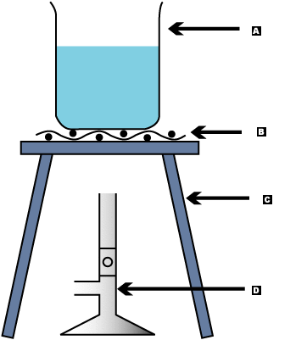

**Activity 2**

Here is a list of four steps to heat liquid in a beaker, but the steps are not in the correct order. Write the numbers 1, 2, 3, 4, and 5 to show the steps in the correct order. The first step has been done for you.

Light the Bunsen burner.

Open the air hole on the Bunsen burner.

1

Place the beaker on the gauze mat.

Rotate the collar on the Bunsen burner so that it is opened and gives a blue flame.

Rotate the collar on the Bunsen burner so that it is closed.